## **CICD: 4 weeks:**

## 1) Version control : git, github( admin)

## 2) Build tool : maven

## 3) CI tool : jenkins

## 4) Artifactory CD : Jfrog

## 5) Code Analyzer : sonarQube

## What is SDLC?

Software development life cycle is a process and it produces software with the highest quality lowest cost in shortest time. SDLC includes a detailed plan for how to develop alter, maintain, and replace a software system.

SDLC involves several distinct stages, including planning, design, building, testing and deployment

## What are SDLC phases?

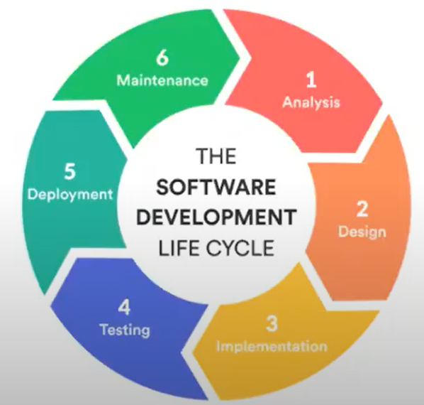

## SDLC models?

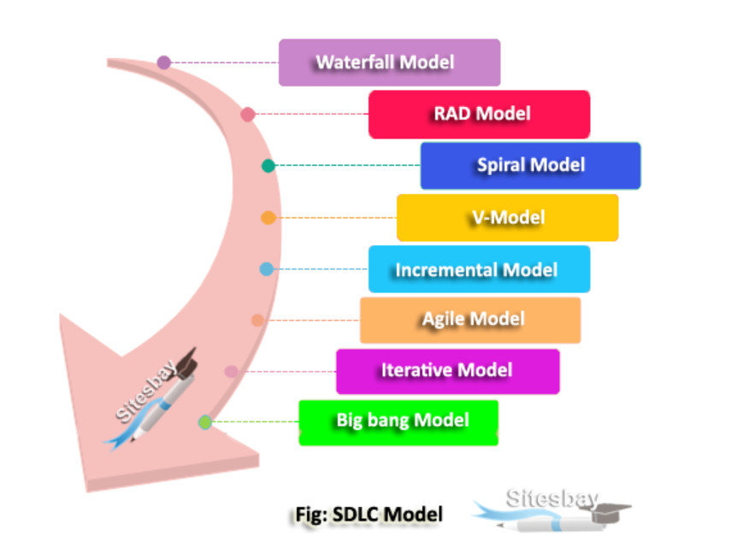

1. Sequence model: follows waterfall model
2. Iterative and incremental model: Agile model

## Waterfall model?

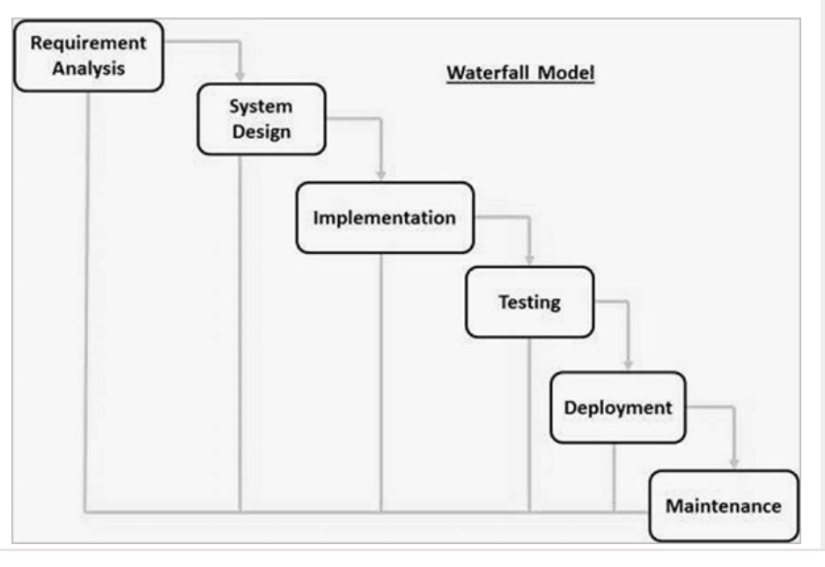

## **Agile Model?**

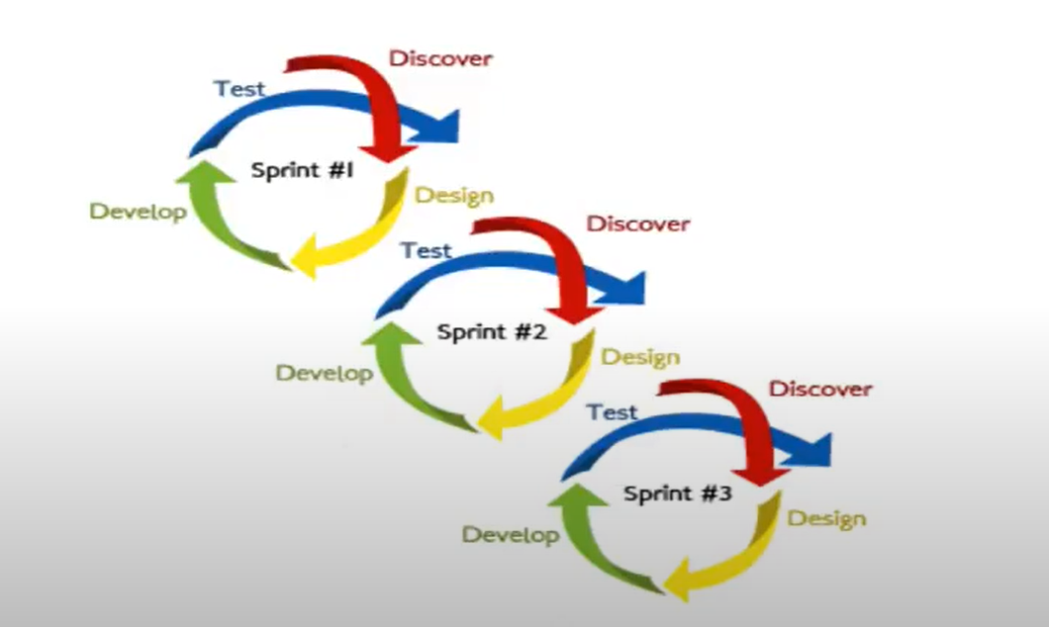

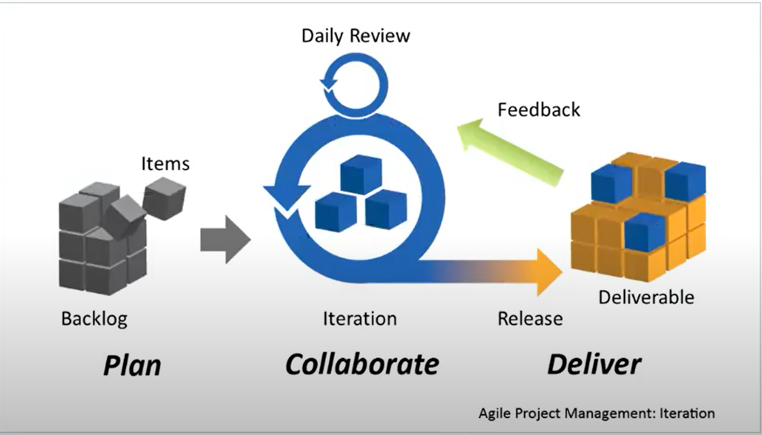

## **Waterfall vs Agile?**

## **Difference between Agile Model and Waterfall Model**

The following table highlights all the important differences between agile model and waterfall model −

|  |  |
| --- | --- |
| **Agile Model** | **Waterfall Model** |
| It separates the project development lifecycle into multiple sprints. | The process of software development is divided into distinct phases. |
| It uses an incremental approach | It is a sequential design process. |
| It is flexible. | It is a structured process, and may be quite rigid at times. |
| It can be understood as a collection of multiple different projects. | The software can be developed as one single project. |
| Changes can be made in project development requirements after initial planning has been completed. | The requirements can't be changed once the project development starts. |
| It follows an iterative development approach. The process of planning, development, prototyping and software development phases can appear multiple times. | The project development phases such as designing, development, testing, are done only once in the waterfall model. |
| The test plan is reviewed after every sprint. | The test plan is not usually discussed during the test phase. |
| The requirements may change and evolve. | This method can be used for projects that have a definite set of requirements and doesn't changes. |
| The process of testing is performed concurrently with software development. | The 'testing' phase comes after the 'build' phase. |
| It uses a product mindset where software product would satisfy the requirements of end customers. | It shows a project mindset, and focuses on completing the project. |
| It would increase the amount of stress in fixed-price scenarios. | The risk is reduced since the price of contracts are fixed by getting the risk agreement in the beginning. |
| It is preferred to work with small and dedicated teams with high amounts of coordination and synchronization. | There is limited team coordination and synchronization. |
| It works well with time and materials, i.e. non-fixed funding. | Business analysis is done to prepare the requirement before beginning it. |
| Products owner with team prepares requirements just about every day during a project. | It is difficult to initiate any changes in the requirements. |
| Project managers are not needed since project can be managed by the entire team. | The process is generally straightforward hence project manager is required. |

## **Agile Principles ?**

* Our highest priority is to satisfy the customer through early and continuous delivery of valuable software.
* Welcome changing requirements, even late in development. Agile processes harness change for the customer’s competitive advantage.
* Deliver working software frequently, from a couple of weeks to a couple of months, with a preference to the shorter timescale.
* Business people and developers must work together daily throughout the project.
* Build projects around motivated individuals. Give them the environment and support they need, and trust them to get the job done.
* The most efficient and effective method of conveying information to and within a development team is face-to-face conversation.
* Working software is the primary measure of progress.
* Agile processes promote sustainable development. The sponsors, developers, and users should be able to maintain a constant pace indefinitely.
* Continuous attention to technical excellence and good design enhances agility.
* Simplicity–the art of maximizing the amount of work not done–is essential.
* The best architectures, requirements, and designs emerge from self-organizing teams.
* At regular intervals, the team reflects on how to become more effective, then tunes and adjusts its behavior accordingly.

## **What is a sprint?**

What is the definition of a sprint in agile? The definition of a sprint is a dedicated period of time in which a set amount of work will be completed on a project. It's part of the agile methodology, and an Agile project will be broken down into a number of sprints, each sprint taking the project closer to completion.

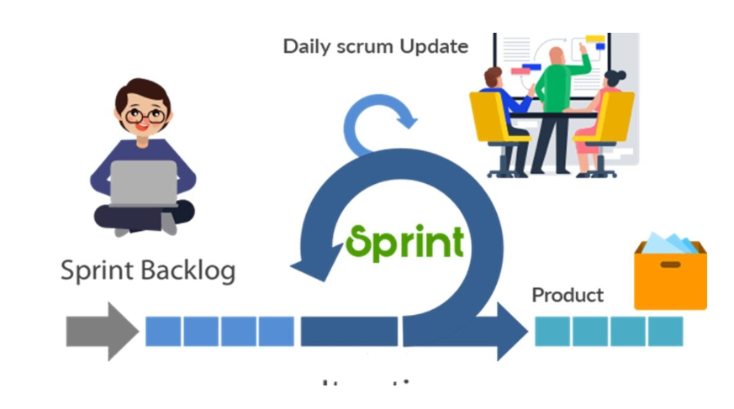

## What is a Release?

A release in Agile refers to the final delivery of a software package after the completion of multiple iterations or sprints. A release can be either the initial development of an application or the addition of one or more complementary features to an existing application.

## What is scrum?***

**Scrum is a framework** that helps agile teams to work together. Using it, the team members can deliver and sustain the complex product. It encourages the team to learn through practice, self-organize while working on the problem. Scum is a work done through the framework and continuously shipping values to customers.

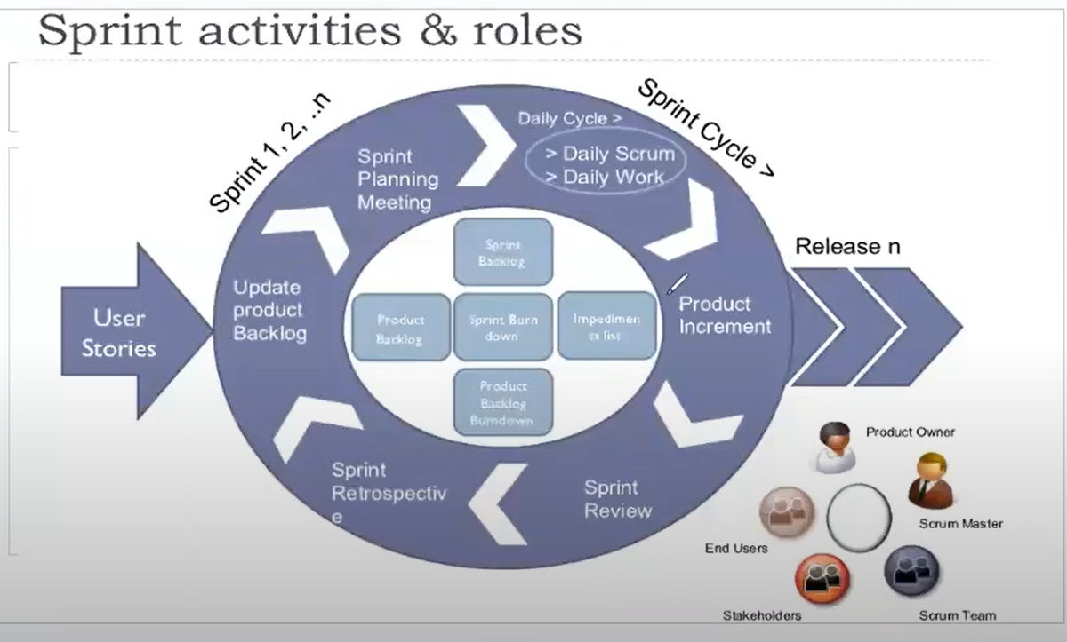

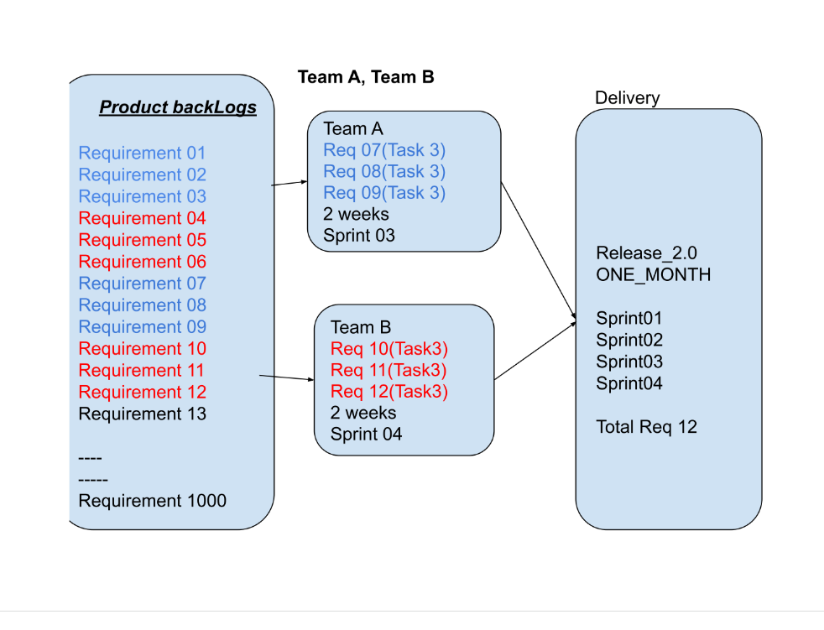

**Without version control**

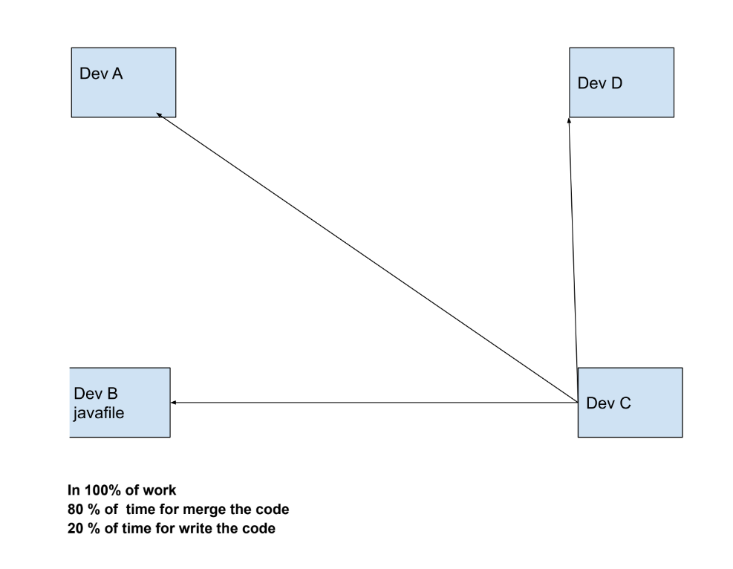

**With version control:**

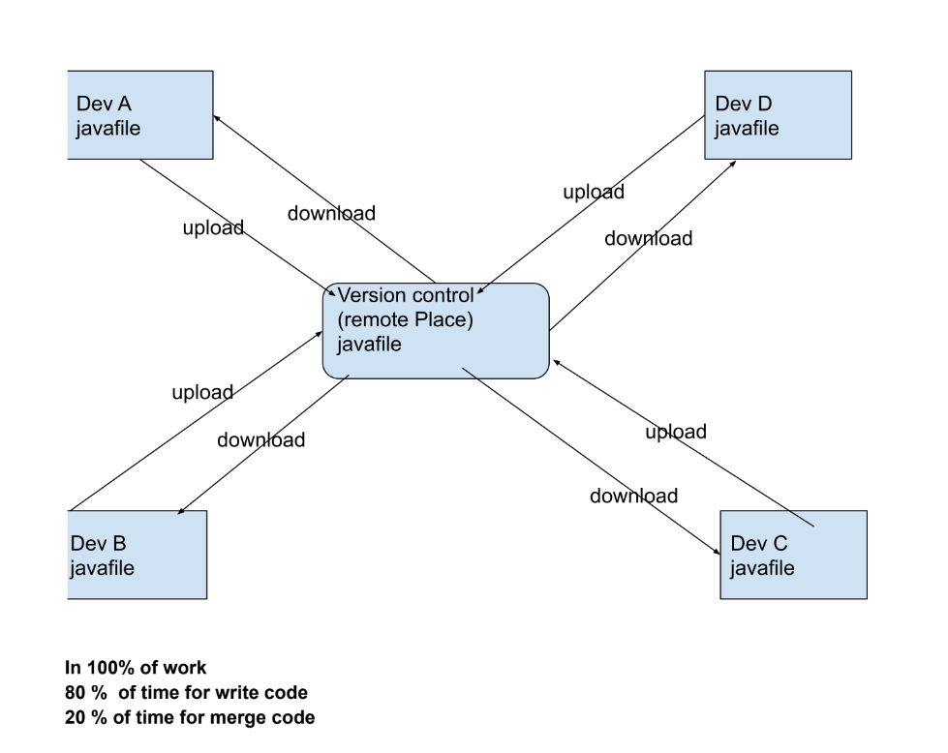

**Byusing version control :**

1. We can create version control for each change with a timestamp
2. We can able to go back older versions at any point of time
3. We can auto merge (if it is possible)
4. We can create a branch

**Type of version controls**

1. Clint and server ARK
2. Distribute ARK

Clint and server ARK